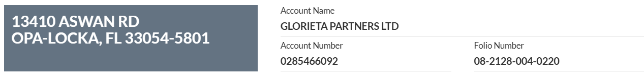
25 unit building at Aswan site
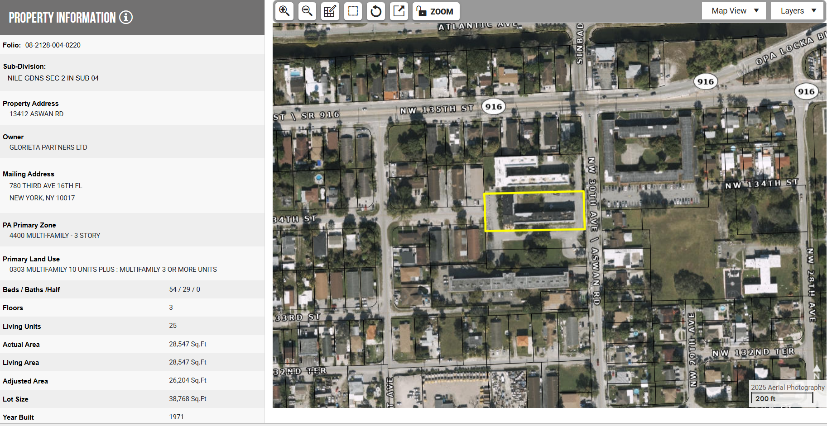

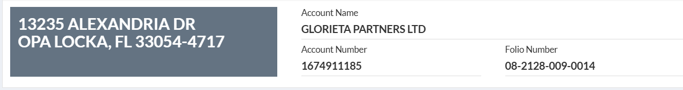
10 unit Building (#9) at Alexandria site
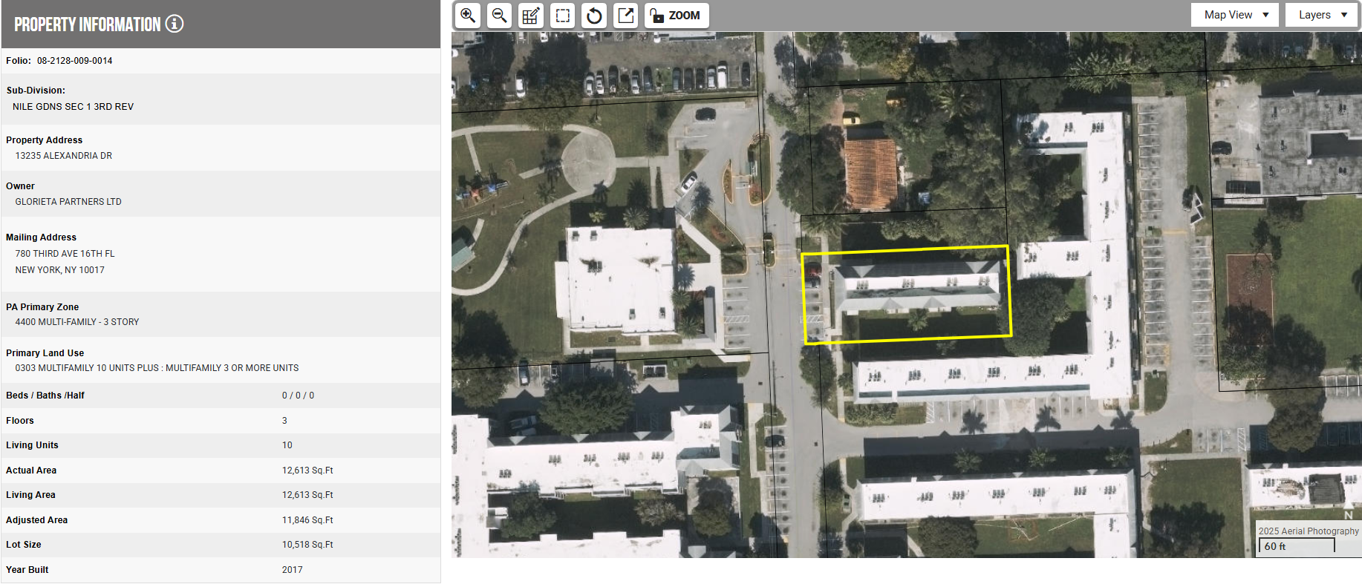
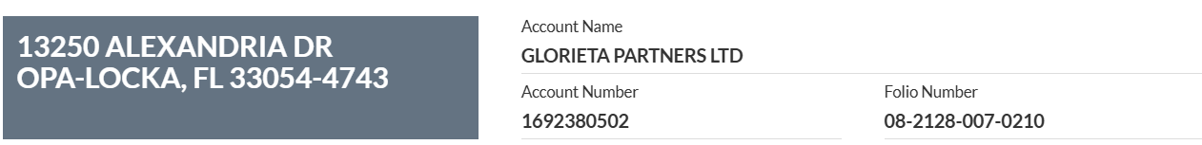
Buildings 7/8 (combined 121 units)
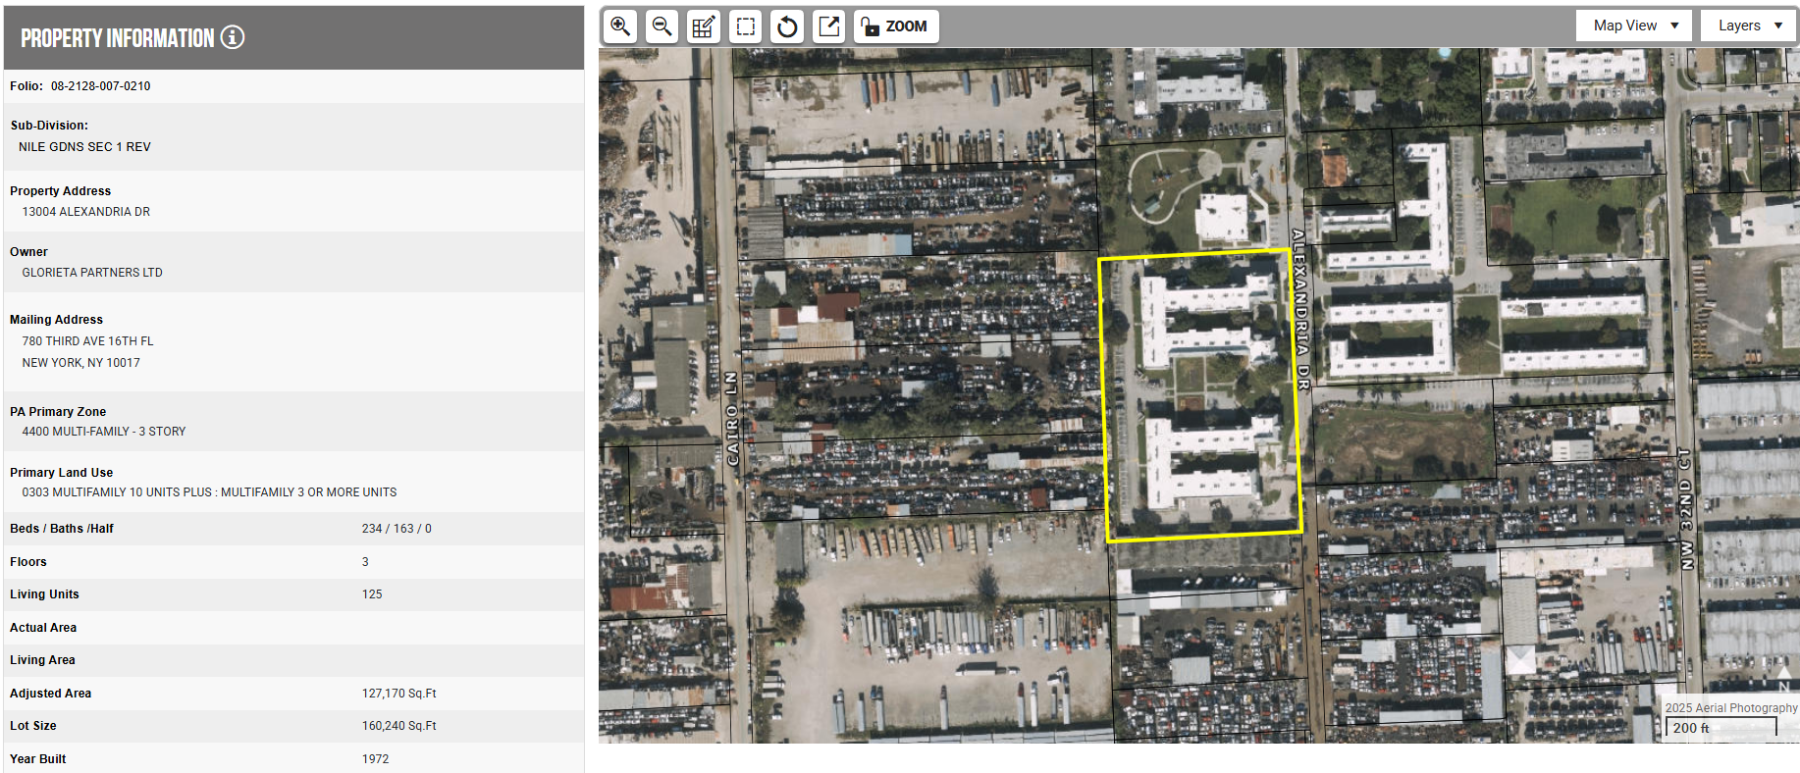
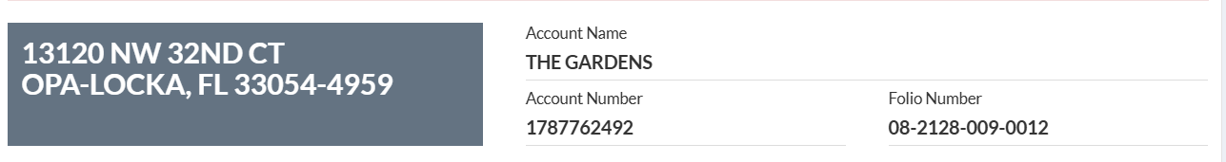
Buildings 3/4/5/6 (combined 140 units)
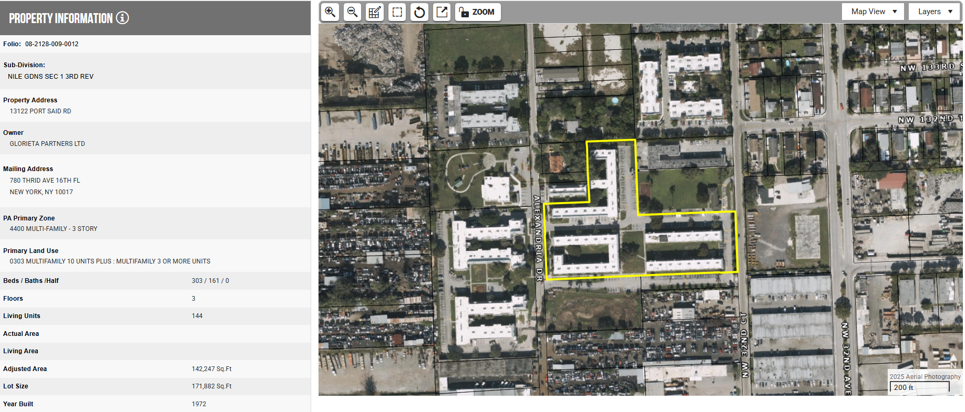

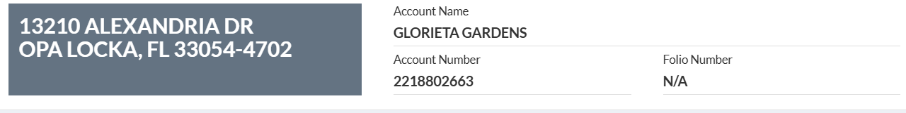
N/A – this is a floating meter that is billed quarterly

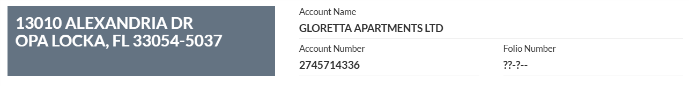
There is no folio number for this meter, which is concerning. It may be a new meter for one or both of the buildings shown under 13250 Alexandria Drive. This is the meter/account that R4 is disputing with the City due to back billing.

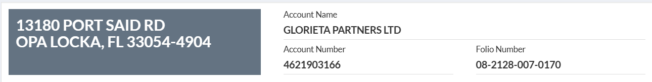
This appears to be for the old office/current maintenance building
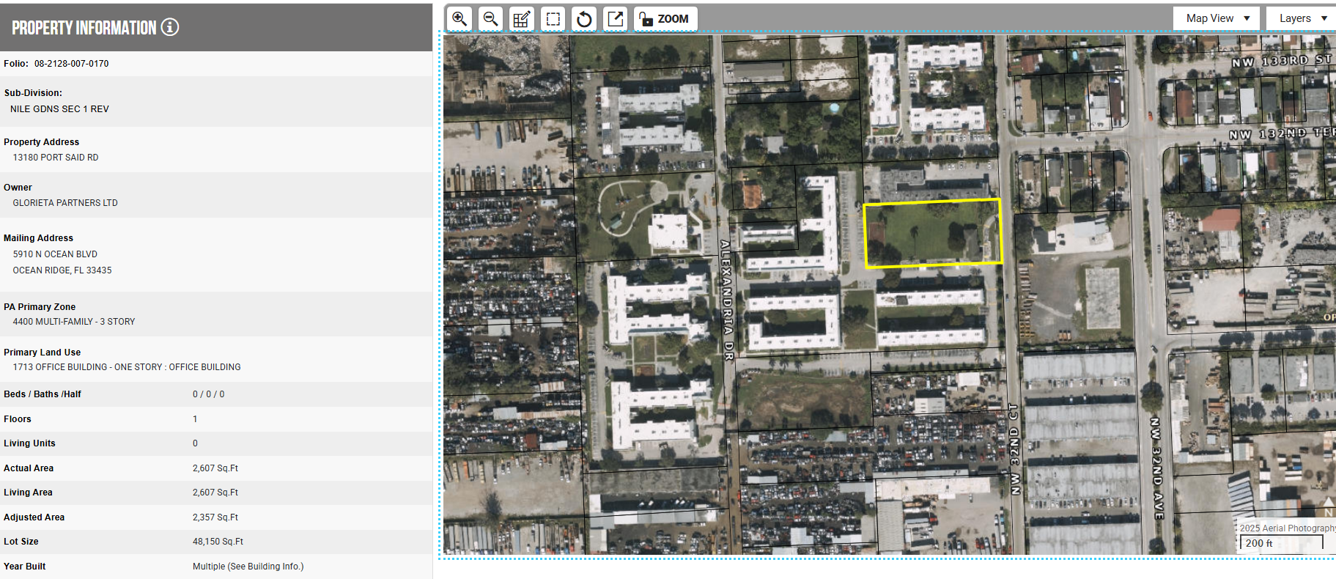

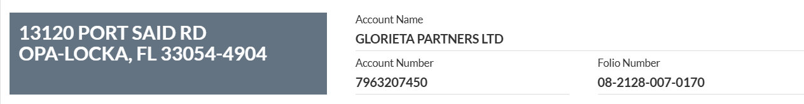
This appears to be a duplicate account for the old office/current maintenance building
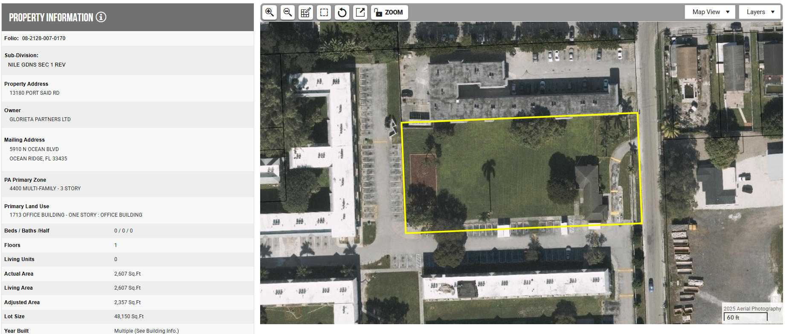

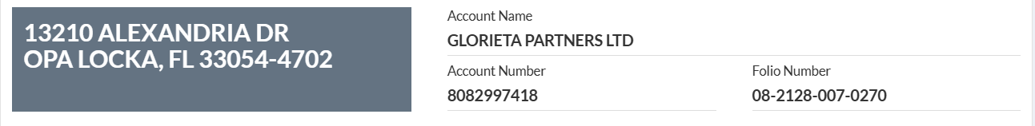
Current leasing office/community building
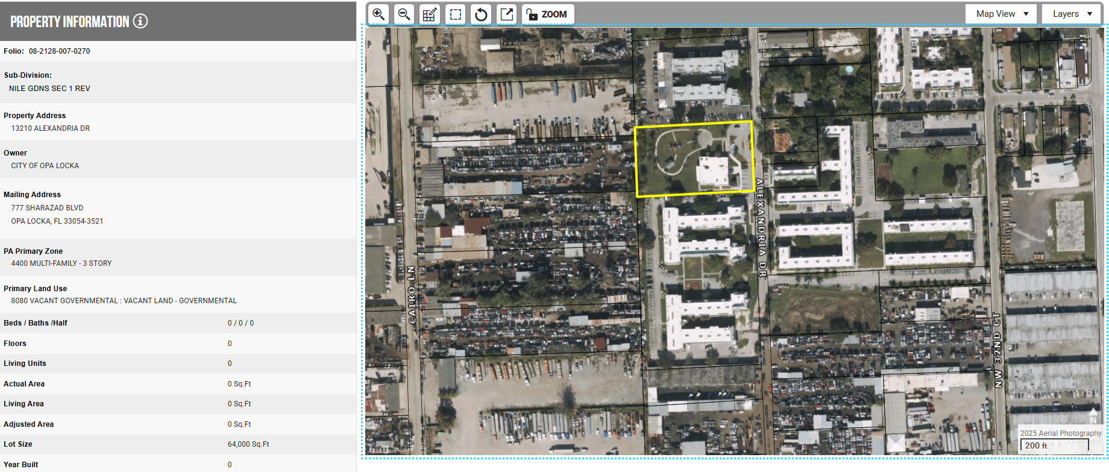

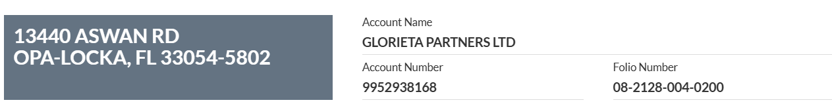
34-unit building at Aswan site
